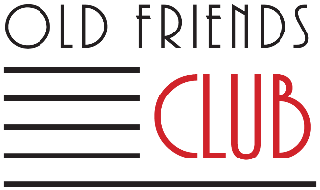
Application for Funding Assistance
Caring for someone through cognitive changes is costly both financially and personally. Some household budgets are strained by care expenses more than others. Old Friends Club changes lives for the better and we want to include everyone who will benefit from the programs. Financial concerns should not be a barrier.
If you would like to be considered for funding assistance, please complete the following:
- Member’s monthly income: $ ______________________
- Number of people dependent on this income: _____________
- Amount Member is able to pay per month: $______________
We keep our fees as low as possible, but we rely on them for sustainability. Please consider whether there are others who can assist financially.
- Others who could help with program fees:
Name: _____________________________________ Monthly Contribution: $__________________
Phone: _______________________________ Email: ___________________________________________
Name: _____________________________________ Monthly Contribution: $__________________
Phone: ______________________________ Email: ____________________________________________
- Total amount family is able to contribute per month: $______________

__________________________________________________ ________________________
Signature Date

Old Friends Club is a nonprofit organization sustained by program fees and donations. Kindly share our story with family and friends. Ask if they would support Old Friends Club with a financial gift or a recurring donation. Old Friends Club is a 501(c)3 nonprofit; donations are tax deductible. EIN 47-472158

